SEPALI MADAGASCAR ANNUAL REPORT 2019

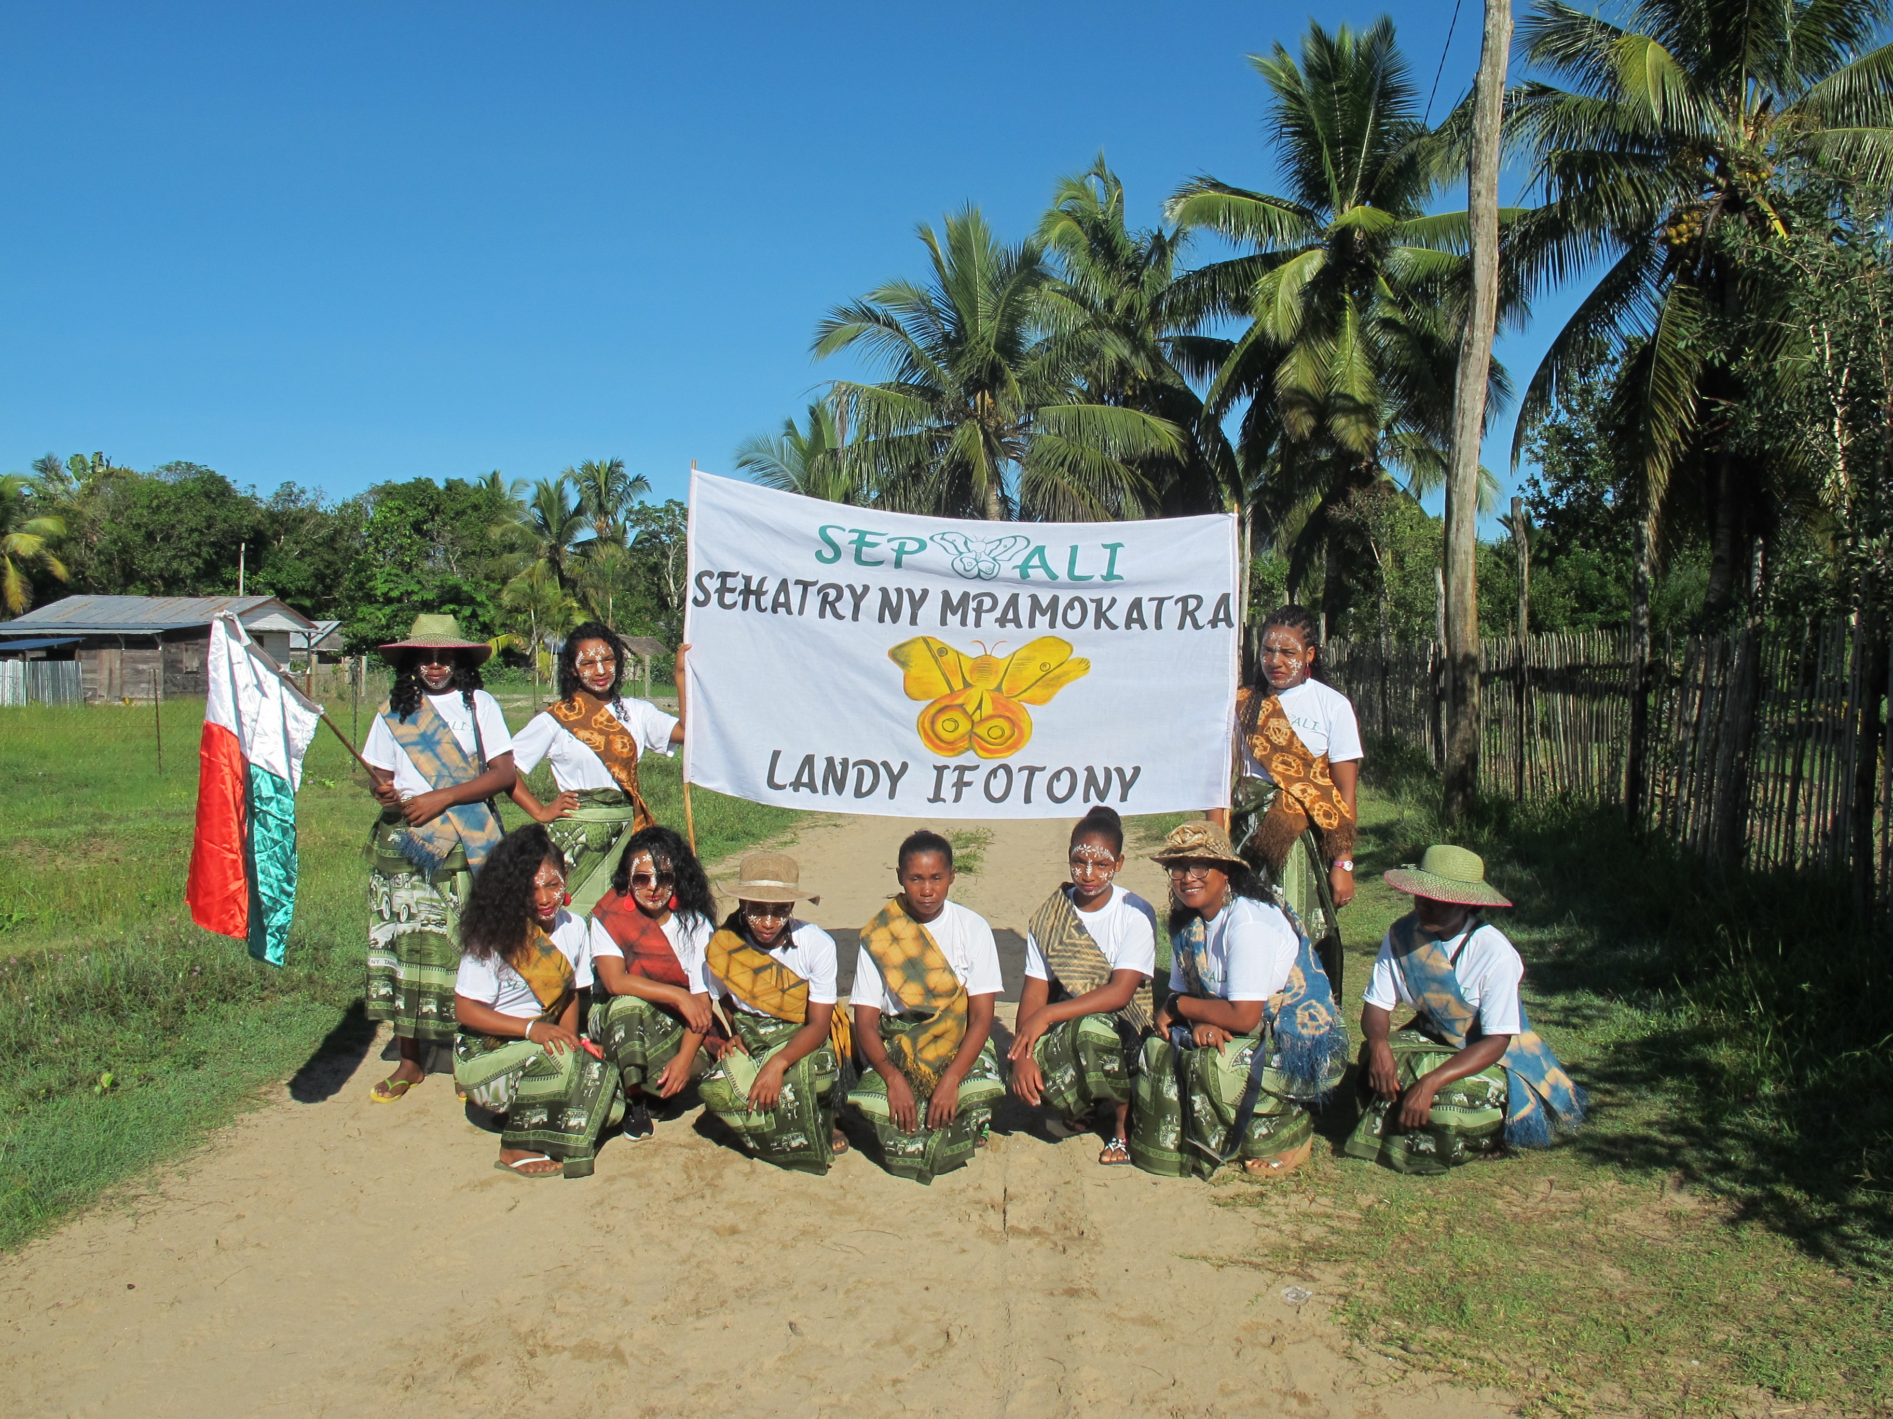

CPCPALI/SEPALI MADAGASCAR ANNUAL REPORT 2019

CPALI/SEPALI Mission:

CPALI/SEPALI Madagascar is a partnership non-profit organization that has been working hand-in-hand in the northern Madagascar since 2009. Therefore, SEPALI Madagascar or ( Sehatry ny MPamokatra Landy Ifotony, www.sepalim.org ) means “Community-based Silk Producer Association” is a small Malagasy NGO with 14 employees in 2019; based in Maroantsetra Madagascar and working with farmers in the rural communities to produce multi species of wild silk.
Established in 2009, CPALI/SEPALI project is designed to provide supplemental sources of income for rural communities that have been economically displaced from the Makira protected area through sustainable development and conservation.
CPALI or (Conservation through Poverty Alleviation, International) (www.CPALI.org) is an international non-profit organization based in WALLA WALLA , founded in 2002, incorporated in Massachusetts in 2003, and approved as a provisionary 501(c)(3) by the US Internal Revenue Service in 2004. CPALI achieved permanent 501(c)(3) status in 2007. The role of CPALI, in addition to its financial and technical support is to develop an international markets as well as linking the SEPALI Madagascar Enterprise to an international buyers.

Our mission in 2019:
The CPALI/SEPALI mission remains the same as we designed in 2007, which was to protect areas of high conservation value by linking the economic livelihoods of poor rural farmers to environ-mental preservation. To do this, our team in Madagascar is continuing to search and valuate new species of endemic silk around the Makira protected Area. Then the women artisans are processing the silk into marketable products.
The CPALI/SEPALI vision is that wild silk will bring many people in the project zone an income that they have never had the opportunity to enjoy, while supporting the protection of this amazing forest and its wildlife.

Resources and Products:
In addition to the plant fiber “ Raffia” processed in 2018, CPALI/SEPALI has also processed different kind of silks such as the native silk species of Antherina suraka, Ceranchia apollina, and the introduced silkworm species of Bombyx morri .
In 2019 , we extended our product base to include three endemic silkworm species , which are Boroceras sp, Deborrhea malagassa and Argema mittrei

Letter from the SEPALI Madagascar Director:

Dear Colleagues, buyers and Donors,

2019 is our 10th year working together in the local communities that bordered the primary rain forest of Makira Protected Area - Madagascar.

According to Wildlife Conservation Society Madagascar (WCS,2002), The Makira Protected Area is approximately 4600 square kilometres in north-eastern Madagascar.
The area forms part of the Eastern Rainforest Biome of the country. This biome is known for its extremely high biological diversity and is to a large part responsible for Madagascar’s status as a mega-diversity ‘Hot Spot’ country.
High numbers of farmers have poor access to markets, education, health care and a non-existent transportation infrastructure keeps rural populations in severe poverty.

So far, Sepali Madagascar is continuing to get a kindly support from CPALI to work in this area.Therefore, 2019 is our second year of transition toward financial independency that CPALI/SEPALI has projected in February 2021.

The action that is waiting for Sepali Madagascar is tough and challenging. Our project has various parameters to effect directly on the farmer`s participation in the program. The main parameters are mostly about surviving situation such us rice production.
The majority of people in our working area are subsistence farmers with their main concentration being on rice production. Very few farmers produce enough rice for the year although they have to sell some of what they produce to buy necessities such as salt, sugar and oil for lamps.
The constant rise in population here and any possibility of farm expansion now limited by laws and the boundary restrictions of the protected area, it is without doubt that new methods of land use and agricultural alternatives are vital to all 83 communities that border the Makira Protected area.

The fluctuation of the cost of vanilla beans becomes a key factor of farmer’s participation in the Sepali program. Fewer farmers contribute to produce and harvest cocoon-silk during 2017 and 2018 because the kilo of vanilla beans was 100 USD. Whereas, in 2019, the vanilla price dropped down to 25 USD a kilo and more farmers get back to us to benefit from the cocoons. Thus showed that our program is a beautiful rescuer for farmers during their hard business time.

Despite the situation in mentioned above, CPALI/SEPALI has never give up. We are struggling to maintaining our original objectives that I can summarize as “ Cocoon-silk enterprise: farming, collecting and transformation of endemic silk to generate income and support local biodiversity”

The Sepali registered farmers have an understanding of their situation and therefore as an alternative to removing more of the forest, they are adopting the SEPALI approach to intercropping trees for wild silk production.
By 2019, 360 farmers from 6 communities around Makira forest, 20 farmers from Bealanana, and 10 villagers around Maroantsetra town are already involved in the project, planting trees on their properties, and harvesting the cocoons sustainably.

I acknowledge Cay Craig, Kerry O`Neil and Docey Lewis for their support for the Sepali application to participate in the Santa Fe exhibition in July 2019. Thanks also to the IFAM committee team for their approuval of the Sepali Madagascar application. Your help allows Lalaina Raharindimby, (our women artisan coordinator) to showcase the “ made in Sepali-Madagascar” products in Santa Fe.
The IFAM exhibition in Santa Fe open the door to a new buyers and brought additional new idea about how to improve our products.

I also acknowledge all the buyers of the Sepali products during 2019 wherever in Madagascar as an FOB or abroad as a hole sales.

In 2020, our team will continue to progress and I promise you a better and new products from the wild silk.
I invite you to follow us and visit our website (mention at the end of this report)
Monthly or whenever you have available time.

Sincerely,


RATSIMBAZAFY Mamy
Project Director of CPALI/SEPALI Madagascar
E-mail: mamycpali@gmail.com

CPALI Timeline:

2003 | - CPALI’s first visit to Madagascar  - Initial meeting with potential stakeholders and partners in Madagascar  - CPALI established as 501(c)3
2004 | - Field surveys at Ranomafana National Park Rainforest  - Silk cooperative established  - CPALI board writes strategic plan
2006 | - Field surveys in Makira/Masoala  - CPALI House established in Maroantsetra
2007 | - Experimental work at CPALI House; Mamy Ratsimbazafy, SEPALIM’s current director, identifies A. suraka host tree  - Field trials continue  - Permanent field team organized  - Demonstration sites established in Maroantsetra  - Three initial target species identified  - Kenney family visits CPALI House
2008 | - Second demonstration site and nursery organized at Manambia  - Mamy completes CPALI training manual  - CPALI competes at the World Bank Development Marketplace  - CPALI achieves permanent 501(c)3 status  - Farmer nursery established in Ambodivoagany
2009 | - 3-year contracts with first farmers  - 7 additional farmers join the project  - First farmer in Amboidivoagany completes transplant of 1,000 trees  - First crop of cocoons sold and exported to Thailand
2010 | - Sehatry ny Mpamokatra Landy Ifotony Madagascar (SEPALIM) is founded by Mamy Ratsimbazafy (current SEPALIM Director)  - SEPALIM introduces silk program in 3 new communities: Marovovonana, Ambinentelo, Amblalmahago  - Provisional Patent filed for non-spun textile  - Non-spun textile juried and accepted into Material ConneXion’s Worldwide libraries
2011 | - CPALI skirt appears in Tara St. James Collection, Fashion Week, NYC  - SEPALIM begins publishing monthly newsletters for farmers  - Tom Corcoran’s CPALI film wins $10,000 prize to support SEPALIM programs  - Peace Corps volunteer Kerry O’Neill joins SEPALIM in Madagascar  - Lalaina Raharindimby appointed to organize women’s program  - 45 farmers plant a minimum of 250 trees and are awarded SEPALM t-shirts  - 10 breeders receive ponchos and rain-proof notebooks to keep records  - 60 women participating in artisan groups support farmers  - Lead farmer and lead artisan programs established  - First farmer’s picnic and awards ceremony  - 4 farmers produce cocoons  - SEPALIM receives SEED Award (UNEP, UNDP, UNESCO)  - SEPALIM Equator Initiative Finalist
2012 | - SEPALIM purchases permanent demonstration site  - 15 farmers produce cocoons  - Partnership with Stanford Design School; 4 students visit SEPALIM for 2 weeks and discuss new products and more efficient ways to make them  - Farmer communities extend to Mahalevona and other sites that border Masoala National Park  - First Global Giving project completed after reaching its $50,000 target!  - SEPALIM bank accepts its first cocoon “deposits”  - William Barclay joins the CPALI board  - Cornell University partners with CPALI/SEPALIM to sample soil from farmer sites and initiate a long-term monitoring program
2013 | - 28 farmers produce cocoons  - 300 farmers join SEPALIM  - SEPALIM welcomes second Peace Corp volunteer, Donald Quinn-Jacobs  - CPALI expands its program mission to include the integrated production of natural resources for food and cash  - SEPALIM begins training and introduction of insects for protein  - SEPALIM initiates biological studies on Ceranchia apollina, a new species of silk- producing moth  - SEPALIM sells 25 m of non-spun textile to Habu Textile  - James Toupin joins CPALI  - CPALI self-imposes an audit by Tonneson and Company  - Kerry O’Neill joins CPALI as Assistant Director  - Heidi MacLean joins the CPALI board and takes position of Chief Financial Officer  - CPALI partners with dConstruct to sell silk for jewelry
2014 | - 32 Farmers producing cocoons, plus 25 collecting cocoons  - CPALI product debut at DWELL Trade Show in Los Angeles  - dConstruct wins eco-choice award from New York Now for wild silk jewelry  - Architects for Humanity partner with CPALI and design a training center for the Maroantsetra demonstration site  - CPALI products are reapproved as Fair Trade by the Fair Trade Federation  - Repeat textile sales to Habu Textiles and dConstruct jewelry company  - CPALI introduces Insects for Food program to farmers  - Manoely Denis finds the previously rare Ceranchia apollina in abundance and organizes 3 communities to collect cocoons and raise pupae  - May Berenbaum, member of CPALI founders board, receives National Medal of Science from President Obama  - First farmers double their average annual household income
2015 | - James Toupin elected president of CPALI Board  - SEPALIM team begins experimenting with both natural and artificial dyes  - CPALI joins the Lemur conservation network  - CPALI debuts at the Architectural Digest’s Home Design Show with Karen Brown  - CPALI attends the Fair Trade Federation conference  - CPALI is featured in Hand-Eye magazine and ASPIRE magazine  - Karen Brown’s silk chair “Natural Selection” is auctioned off for $1,600  - Moth Matching Kickstarter campaign is launched and funded  - dConstruct launches a new jewelry line of SEPALIM silk in green and purple  - Mamy’s rearing book is translated into English  - Tim Barclay’s children’s book on wild silk farming translated into Malagasy  - CPALI silks are Certified Wildlife Friendly  - CPALI develops table runners and placemats and sells the first line to ABC Carpet and Home  - CPALI launches a wholesale site  - International design consultant Docey Lewis begins to experiment with SEPALIM silks and creates a new line of dyed products  - CPALI sells over $20,000 of silk in 2015 to individuals and retailers  - SEPALIM silk production increases from 300 meters in 2014 to 490 meters in 2015  - SEPALIM’s silk production workshops run every week in 2015 with a team of local artisans
2016 | - Docey Lewis travels to Madagascar to teach SEPALIM how to dye textiles  - Pricing of textiles re-evaluated and lowered to increase volume sales  - Raffia textiles are adopted into product mix  - Madagascar team receives a grant from US Embassy in Madagascar to purchase looms and sewing machines to take program directly to villages  - Docey Lewis develops 6 product lines for SEPALIM that include lighting materials, handbags, gift ties and tags, textile arts for the leisure industry and fine arts, and art papers for artists  - CPALI establishes commercial partnerships with Color by Amber and Gold Leaf Design  - SEPALIM becomes a Full Circle partner  - Rouge Foundation, WCS, and CPALI establish children’s conservation art program  - Landy Dia, silk farming book by Tim Barclay, is introduced in village schools and libraries; SEPALI Madagascar holds two group readings at its headquarters  - Rogue Foundation, CPALI, and WCS auction paintings and SEPALIM’s textile arts at the Rogue Gallery in New York City  - CPALI’s donors surpass all previous giving, allowing Docey Lewis to return to Madagascar in 2017 and continue team training  - CPALI begins to build Tanana brand
2017 | - Cyclone Enawo devastates northeastern Madagascar on 3 March. CPALI donors donate $3,000 to Medair towards the purchase of 150 wash kits for immediate use. In addition, SEPALIM provides materials and labor to repair a local bridge. Using funds from donors, SEPALIM purchases and ships 8 new mattresses to the Ambinentelo hospital.  - Docey Lewis and Catherine Craig return to Madagascar in April to hold a second artisans workshop in Maroantsetra. The team purchases raffia mats from a village outside Antananarivo that Docey visited to extend a SEPALIM partnership.  - Docey teaches the SEPALIM team how to build a standing loom that is later copied with funds awarded by the US Ambassador. Two additional looms are built.  - Docey Lewis shows CPALI/SEPALIM cocoon textiles at NY ICFF artisan showcase and attracts Donna Karan with sales to Urban Zen.  - IBU designs and sells shibori raffia cosmetic bags made by Madagascar and US teams.  - Mamy and Lalaina participate in Aid to Artisans Market readiness program in New York. The training includes market trends, pricing, and critiques of SEPALIM products by experienced buyers.  - The Insects for Food partnership holds working meeting at the Madagascar Biodiversity Center focused on building insect rearing enclosures, collecting local crickets, and exploring potential funding opportunities in Madagascar.  - SEPALI plants Tsidimy seeds to begin raising “Sakondry” at SEPALIM demonstration site.
2018 | - Linda Cartwright visits SEPALIM and writes a comprehensive article about the program for Wild Fibers Magazine  - Docey returns to Madagascar to help team prepare for NY Now, held in August  - Tanana welcomes Sanjo Silk and Diane Sanderson to the team. Sanjo is now the Canadian and US distributor for all undyed silk.  - Whitman College's Sheehan Gallery hosts "Requiem for a Rainforest." The exhibit includes photographs by Nick Garbutt and Safidy Andrian, silk sculptures by Mandy Coopes-Martin, and non-spun cocoon silk and raffia textiles. Catherine Craig gives a lecture for Whitman's Parents Day.  - Docey Lewis visits Whitman College for two days to give two lectures highlighting her work with SEPLIM as well as her career as a textile designer and artist  - Safidy Andrian visits Whitman College to discuss his work with the SEPALIM team as well as his career as a photojournalist in Madagascar  - CPALI exhibits Safidy Andrian's photographs at the Columbia Arts Gallery "identity" exhibit in addition to cocoon-silk and raffia textiles  - Lalaina Raharindimby selected by the International Folk Art Market to represent the SEPALIM team and sell products in 12-14 July 2019. Please join us for this festive event!  - SEPALIM program website is revised and beautiful! www.sepalim.org  - CPALI sells 97 items and 3,207 units. Sales returned $28,663 to the program.
2019 | - Sepali participated to an yearly international meeting of ATBC 2019 (Association of Tropical Biology and Conservation. Mamy Ratsimbazafy ( Sepali Director) did presentation about Sepali`s wild silk program.  - Raharindimby Lalaina (women artisans coordinator of Sepali Madagascar) attended to IFAM (International Folk Art Market ) exhibition in Santa Fe. It was an opportunity for Sepali Madagascaar to showcase the silk and raffia products produced by the local artisans of Maroantsetra.  - Both Mamy Ratsimbazafy and Lalaina Raharindimby went in Sandrandahy – Ambositra ( in the Southern Madagascar) to attend a training about the natural dyeing process.  - Lalaina Raharindimby attend two weeks training about the Raffia dyeing process and plant dye species inventory.

Financial report 2019:
(Currency in USD)
Month | cocoon purchase | electricity | fee | internet | labor | phone | rent | salary | supplies | transportation | Grand Total
jan | 0.00 | 31.93 | 1.25 | 52.00 | 0.00 | 38.96 | 163.55 | 2152.40 | 36.66 | 415.24 | 2891.99
Feb | 1753.25 | 34.15 | 380.27 | 52.00 | 41.60 | 38.96 | 163.55 | 2071.40 | 32.50 | 0.00 | 4567.68
Mar | 129.87 | 33.62 | 665.42 | 51.95 | 10.39 | 38.96 | 163.38 | 2164.78 | 215.84 | 0.00 | 3474.21
Apr | 0.00 | 34.09 | 390.15 | 51.95 | 31.17 | 38.96 | 163.38 | 1401.00 | 26.88 | 0.00 | 2137.57
May | 0.00 | 34.12 | 172.11 | 54.05 | 18.92 | 40.54 | 170.00 | 2926.26 | 392.97 | 472.16 | 4281.14
jun | 851.35 | 35.58 | 18.86 | 54.05 | 10.81 | 40.54 | 170.00 | 2198.84 | 606.22 | 0.00 | 3986.25
jul | 0.00 | 76.13 | 347.42 | 52.06 | 0.00 | 39.04 | 163.72 | 2232.00 | 58.82 | 729.62 | 3698.81
Aug | 0.00 | 42.95 | 294.95 | 52.06 | 10.41 | 39.04 | 163.72 | 2232.00 | 18.22 | 24.73 | 2878.07
Sep | 0.00 | 49.78 | 401.16 | 55.52 | 52.75 | 41.64 | 174.63 | 2096.63 | 1485.29 | 425.04 | 4782.43
Oct | 788.17 | 45.22 | 151.78 | 55.52 | 11.10 | 41.64 | 174.63 | 2171.58 | 18.05 | 388.95 | 3846.65
Nov | 483.50 | 43.43 | 8.48 | 56.88 | 17.06 | 42.66 | 178.90 | 2172.00 | 241.75 | 0.00 | 3244.67
Dec | 1279.86 | 41.46 | 161.58 | 56.88 | 11.38 | 42.66 | 178.90 | 2203.22 | 51.19 | 780.72 | 4807.85
Grand Total | 5286.01 | 502.47 | 2993.42 | 644.94 | 215.60 | 483.62 | 2028.32 | 26022.10 | 3184.40 | 3236.45 | 44597.33

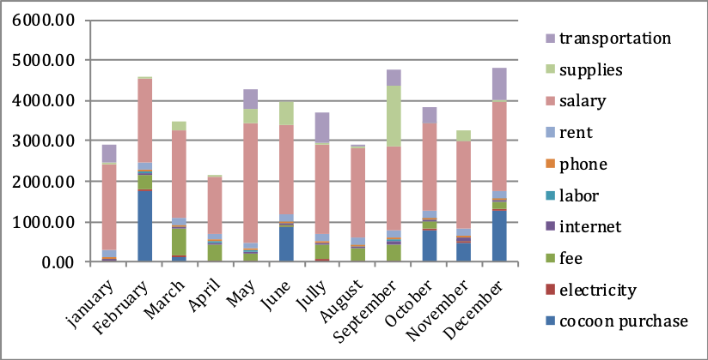

Wiring and spending of Sepali Madagascar:
The table below summarizes all the wiring to the Sepali Madagascar Bank accounts. It includes both of the NGO and enterprise account.

The yellow rows are the monthly Spending of Sepali program in Madagascar, the blue rows are transactions from Sanjo Silk (SPALIM's major marketing parter) and Grey rows are transactions from CPALI.
The currency is in Malagasy ariary(MGA)
NUMBER | EXPLANATION | DATE | NAME OF DEPOSITE | DEPOSITE(ariary) | EXPENSE BY MONTH(ariary) | MONEY LEFT(ariary)
1 | Money left for 2017 | Dec 31st 2017 |  |  |  | 7540000
2 | sepali spending for January 2018 |  |  |  | 6954920 | 585080
3 | Cpali deposite | Feb 21st 2018 | CpALI | 11848350 |  | 12433430
4 | sepali expense for February 2018 | Feb 28th 2018 |  |  | 11613268 | 820162
5 | Cpali deposite | Mar 1st 2018 | CpALI | 13410393 |  | 14230555
6 | sepali expense for March 2018 | Mar 31st 2018 |  |  | 13467116 | 763439
7 | Cpali deposite | Apr 12th 2018 | CpALI | 12315090 |  | 13078529
8 | Cpali deposite | Apr 17th 2018 | CpALI | 2463018 |  | 15541547
9 | sepali expense for April | Apr 30th 2018 |  |  | 11355968 | 4185579
10 | Cpali deposite | May 16th 2018 | CpALI | 12384750 |  | 16570329
11 | Cpali deposite | May 31st 2018 | CpALI | 15892125 |  | 32462454
12 | sepali expense for May | May 31st 2018 |  |  | 13778618 | 18683836
13 | Cpali deposite | Jun 22nd 2018 | CpALI | 7970000 |  | 26653836
14 | Cpali deposite | Jun 28th 2018 | CpALI | 9558000 |  | 36211836
15 | sepali expense for June | Jun 31st 2018 |  |  | 18112368 | 18099468
16 | Cpali deposite | Jul 13th 2018 | CpALI | 9573000 |  | 27672468
17 | sepali expense for Jully | Jul 30th 2018 |  |  | 10451568 | 17220900
18 | Cpali deposite | Aug 23rd 2018 | CpALI | 9501000 |  | 26721900
19 | sepali expense for August | Aug 31st 2018 |  |  | 13510588 | 13211312
20 | Cpali deposite | Sep 13th 2018 | CpALI | 11403000 |  | 24614312
21 | sepali expense for September | Sep 30th 2018 |  |  | 9737968 | 14876344
22 | SANJO SILK deposite | Oct 10th 2018 | Sanjo silk | 10926428 |  | 25802772
23 | Cpali deposite | Oct 23rd 2018 | CpALI | 2680000 |  | 28482772
24 | sepali expense for October | Oct 31st 2018 |  |  | 11955168 | 16527604
25 | Cpali deposite | Nov 14th 2018 | CpALI | 13704000 |  | 30231604
26 | Cpali deposite | Nov 28th 2018 | CpALI | 8765000 |  | 38996604
27 | sepali expense for November | Nov 30th 2018 |  |  | 11648668 | 27347936
28 | Cpali deposite | Dec 13th 2018 | CpALI | 16840000 |  | 44187936
29 | Cpali deposite | Dec 18th 2018 | CpALI | 16910000 |  | 61097936
30 | sepali expense for December | Dec 31st 2018 |  |  | 16219568 | 44878368
 | MONEY LEFT FOR 2019 |  |  |  |  | 44878368
31 | sepali expense for January 2019 | Jan 30st 2019 |  |  | 14968734 | 29909634
32 | SANJO SILK deposite | Feb 25th 2019 | Sanjo silk | 9047270 |  | 38956904
33 | sepali expense for February 2019 | Feb 28th 2019 |  |  | 17624473 | 21332431
34 | sepali expense for March 2019 | Mar 31st 2019 |  |  | 13375697 | 7956734
35 | sepali expense for April | Apr 30th 2019 |  |  | 7924242 | 32492
36 | Cpali deposite | May 14th 2019 | CpALI | 16026823 |  | 16059315
37 | Cpali deposite | May 29th 2019 | CpALI | 12211500 |  | 28270815
38 | sepali expense for May | May 31st 2019 |  |  | 16128806 | 12142009
39 | Cpali deposite | June21st 2019 | cpali | 12089000 |  | 24231009
40 | sepali expense for June | June 30th 2019 |  |  | 15715000 | 8516009
41 | SANJO SILK deposite | Jul 17th 2019 | Sanjo silk | 9450192 |  | 17966201
42 | sepali expense for Jully | Jul 31st 2019 |  |  | 14210844 | 3755357
43 | sepali expense for August | Aug 30th 2019 |  |  | 2482220 | 1273137
44 | Cpali deposite | Sep 2nd 2019 | cpali | 14212000 |  | 15485137
45 | Cpali deposite | Sep 23rd 2019 | cpali | 18010000 |  | 33495137
46 | sepali expense for September | Sep 31st 2019 |  |  | 25801668 | 7693469
47 | SANJO SILK deposite | Oct 25th 2019 | Sanjo silk | 6467735 |  | 14161204
48 | sepali expense for October | Oct 31st 2019 |  |  | 13855844 | 305360
49 | Cpali deposite | Nov 4th 2019 | cpali | 12306000 |  | 12611360
50 | sepali expense for November | Nov 30th 2019 |  |  | 11424252 | 1187108
51 | Cpali deposite | Dec 4th 2019 | cpali | 12131000 |  | 13318108
52 | Cpali deposite | Dec 6th 2019 | CpALI | 8685000 |  | 22003108
53 | sepali expense for December | Dec 31st 2019 |  |  | 20370385 | 1632723
 | MONEY LEFT IN JANUARY 2020 |  |  |  |  | 1632723
53 | cPALI deposite for January | Jan 23rd 2020 | cpali | 12159000 |  | 13791723
54 | sepali expense for January | Jan 30th 202 |  |  | 9017660 | 4774063
55 | CPALI deposite for February | Feb 27th 2020 | CPALI | 10719000 |  | 15493063
56 | sepali expense for February | Feb 28th 2020 |  |  | 13721049 | 1772014
57 | CPALI deposite for March | Mar 5th 2020 | CPALI | 12302500 |  | 14074514
58 | CPALI deposite for April and May | Mar 19th 2020 | cpali | 21408000 |  | 35482514
59 | sepali expense for March | Mar 31st 202 |  |  | 9783682 | 25698832
60 | sepali expense for April | Apr 30th 2020 |  |  | 11660194 | 14038638
61 | SANJO silk deposite | May 27th 2020 | SANJO SILK | 12299265 |  | 26337903
62 | sepali expense for May | May 30th 2020 |  |  | 18182345 | 8155558
63 | CPALI deposite for June | Jun 3rd 2020 | cpali | 10847383 |  | 19002941
64 | sepali expense for June | Jun 31st 2020 |  |  | 12275000 | 6727941

Donor Report
Dear Donors, Partners, and Buyers

On behalf of CPALI/SEPALI Madagascar, I gratefully acknowledge for your
support and kindly contribution to develop our project during 2019.

Without your support, CPALI/SEPALI Madagascar would not have been able to
Implement our “Reforestation and Wild silk production” program in the ten
communities bordering the Makira and Masoala protected areas.

I hope that you will continue supporting our program in the coming years.

Sincerely,
RATSIMBAZAFY Mamy
Project Director CPALI/SEPALI Madagascar
E-mail: mamycpali@gmail.com
Website: www.sepalim.org; www.cpali.org; www.wildsilkmarket.org
Tel: (264)320445246
Address: BP 512 Ambatomasina Maroantsetra-
Analanjirofo - Madagascar

$30,000+
Kenney Family

$1,000-$10,000
William Barclay | Carolyn Pidduck | Judy Munzig | May Berenbaum
Jane Pidduck | Nancy Merrick | Elinor Farquhar

$500-$1,000
Brent Opell | Willam Kenney | Janet and Wylie Greg | Helen Kenney
Henry and Sue Bass | Larry Wiberg

$1-$500
Margery M. Craig | Gallery Unconfined | Anonymous | Claire Kremen
Caroline Kenney | Leslie Brunetta | Carole Levin | Catherine Caufield
Douglas Kolozsvari | Parry Grossman | Judy Craig | Susan Bell
Michael Cain | Anne Vanderstoep | Gonzalo Giribet | Angela Pava
Diana Sanderson | Ann Hanson | William Pfitsch | Darlene Benson
Joan Shulmann | Mary Sears | Catherine Leslie | Frances Chew

