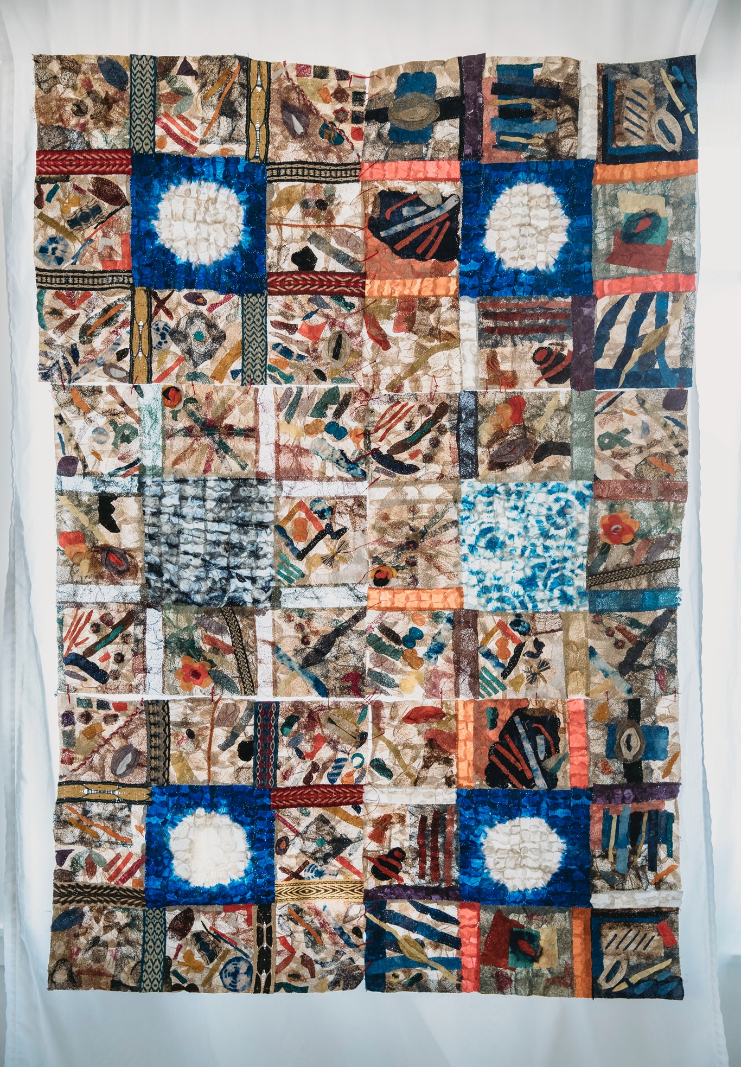

CONSERVATION THROUGH
POVERTY ALLEVIATION,
INTERNATIONAL

ANNUAL REPORT 2020
CPALI Mission
Conservation through Poverty Alleviation, International (http://www.CPALI.org) is an international non-profit organization that identifies, develops, and implements new means of income generation for impoverished farmers living in areas of high biodiversity and conservation value. We were founded in 2002, incorporated in Massachusetts in 2003, and approved as a provisionary 501(c)(3) by the US Internal Revenue Service in 2004. CPALI achieved permanent 501(c)(3) status in 2007.
CPALI is dedicated to a community-centered approach to conservation. Our mission is to help impoverished communities farm and transform endemic resources to create sustainable enterprises that benefit farm families and protect endangered ecosystems.
The CPALI vision is to build and test the effectiveness of an innovative environment-conserving enterprise. We have divided our efforts into four areas:
- piloting a silk gardening and textile production enterprise in northeastern Madagascar
- international marketing of the wild-silk products from Madagascar
- building recognition that endemic resource farming can be a successful international conservation strategy
- building SEPALI Madagascar to be a self-supporting conservation enterprise

Resources and Products: The CPALI method begins with identifying native species of plants and animals near the borders of protected areas that can be farmed and developed for commercial products. CPALI’s first product was silk cocoons produced by the native silk moth Antherina suraka. We added Ceranchia apollina and Borocera cajani, which are also collected sustainably.
In 2017, we extended our product base to include Bombyx mori and two additional native species of silkworm as well as raffia and raffia textiles. Raffia is a product of the raffia palm, of which there are about 20 species in Madagascar. We are currently germinating raffia seeds to plant a raffia nursery.
Human Organizations and Incentive Structure: In Maroantsetra, we helped establish an independent local NGO, "Sehatry ny Mpamokatra Landy Ifotony” (Association of Wild Silk Producers of Madagascar), or SEPALIM, which manages training, raw materials growth and distribution, textile production, and cocoon purchases and develops additional income opportunities. In 2015, SEPALIM established a product workshop that now employs approximately 11 artisans.

Cover: The SEPALI Madagascar team worked hard through 2020 to keep production going despite Covid's impacts. The mosaic textile on the cover of this Annual Report was made by every member of the team and a tribute to their resilience.

LETTER FROM THE PRESIDENT
The past year has been difficult for us all and those challenges continue in Madagascar, in part due to lack of Covid vaccines. In June of this year, the Malagasy president finally decided to allow vaccines in the country. We have learned that those have been distributed to vaccinate the military and high government officials. We have also learned that many deaths and incidents of illness are not reported or have assumed to be due to malaria or chikungunya.
We had considered closing the workshop, but the team wanted it to stay open as they felt safer working there than at home and they needed their salaries. Mamy required hand-washing and changing masks 4 times a day. Both Mamy and Lalaina were very sick with Covid but fortunately they recovered. Many members of the team dropped-out of work but all returned within 2 weeks. A major center of contact was the town market where team members had lunch. With funds raised through Global Giving, SEPALI was able to provide lunches for team members. We also established a worker's fund that team members could use for health care. Fortunately, we have not lost any members of the team due to Covid.
Vanilla is the main cash crop for most local farmers in our area. Since I started working in Madagascar, I have experienced 2 cycles of the rise and fall of vanilla prices. The farmer's program was initiated around 2011 after the 2007 crash in the vanilla prices. In 2013, the vanilla market began to rise and we lost our silk producers when they once again returned to vanilla farming. In 2019, the returns from the vanilla market bottomed out again and once again, cocoon purchases became the only source of cash income for farmers. We are, for a second time, a lifeline for farmers. Although the program was organized to mediate market fluctuations, the 5-year cycle and range of price changes have made it difficult for SEPALIM to balance farmers’ needs.
As you will realize from our marketing report, our sales dropped by 2/3's this year. The upside, however, is that we have completely revamped our marketing program. I was lucky enough to hire Kessa Laxton who has completely reorganized our efforts here in t
he US and Canada. Check out the marketing report if you are interested in more details as well as our updated website, www.tananasilk.com that will be fully operational in August.
In addition, a group of researchers at the University of Bern working on livelihoods has decided to take up this problem head on and invited CPALI/SEPALI Madagascar to collaborate with them. They will try to mitigate agricultural expansion into forests by revising agricultural cooperative law at the local and national level. We will participate in the project and hope that our insights will help.

CPALI TIMELINE
2003 | - Cay’s first visit to Madagascar  - Initial meeting with potential stakeholders and partners in Madagascar CPALI established as 501(c)3
2004 | - Field surveys at Ranamafana National Park Rainforest silk cooperative established CPALI board writes strategic plan
2006 | - Field surveys in Makira/Masoala  - CPALI House established in Maroantsetra
2007 | - Experimental work at CPALI House; Mamy Ratsimbazafy, SEPALIM’s current director, identifies A. suraka host tree  - Field trials continue  - Permanent field team organized  - Demonstration sites established in Maroantsetra Three initial target species identified
2008 | - Second demonstration site and nursery is organized at Manambia Mamy completes CPALI training manual  - CPALI competes at the World Bank Development Marketplace CPALI achieves permanent 501(c)3 status  - Farmer nursery established in Ambodivoangy
2009 | - 3-year contracts with first farmers  - 7 additional farmers join the project  - First farmer in Ambodivoangy completes transplant of 1,000 trees First crop of cocoons sold and exported to Thailand
2010 | - Sehatry ny Mpamokatra Landy Ifotony Madagascar (SEPALIM) is founded by Mamy Ratsimbazafy, (current SEPALIM Director) SEPALIM introduces silk program in 3 new communities: Marovovonana, Ambinentelo, Amblalmahago  - Provisional Patent filed for non-spun textile  - Non-spun textile juried and accepted into Material ConneXion’s Worldwide libraries
2011 | - CPALI skirt appears in Tara St. James Collection, Fashion Week, NYC SEPALIM begins publishing monthly newsletters for farmers  - Tom Corcoran’s CPALI film wins $10,000 prize to support SEPALIM programs Peace Corps volunteer Kerry O’Neill joins SEPALIM in Madagascar  - Lalaina Raharindimby appointed to organize women’s program  - 45 farmers plant a minimum of 250 trees and are awarded SEPALM t-shirts 10 breeders receive ponchos and rain-proof notebooks to keep records  - 60 women participating in artisan groups are paid for making baskets and nets to support farmers  - Lead farmer and lead artisan programs established  - First farmer’s picnic and awards ceremony  - 4 farmers produce cocoons  - SEPALIM receives SEED Award (UNEP, UNDP, UNESCO)  - SEPALIM Equator Initiative Finalist
2012 | - SEPALIM purchases permanent demonstration site 15 farmers produce cocoons  - Partnership with Stanford Design School; 4 students visit SEPALIM for 2 weeks and discuss new products and more efficient ways to make them  - Farmer communities extend to Mahalevona and other sites that border Masoala National Park  - First Global Giving project completed after reaching its $50,000 target! SEPALIM bank accepts its first cocoon “deposits”  - William Barclay joins the CPALI board  - Cornell University partners with CPALI/SEPALIM to sample soil from farmer sites and initiate a long-term monitoring program
2013 | - 28 farmers produce cocoons (to date) 300 farmers join SEPALIM  - SEPALIM welcomes second Peace Corp volunteer, Donald Quinn-Jacobs  - CPALI expands its program mission to include the integrated production of natural resources for food and cash  - SEPALIM begins training and introduction of insects for protein  - SEPALIM initiates biological studies on Ceranchia apollina, a new species of silk- producing moth  - SEPALIM sells 25 m of non-spun textile to Habu Textile James Toupin joins CPALI  - CPALI self-imposes an audit by Tonneson and Company Kerry O’Neill joins CPALI as Assistant Director  - Heidi MacClean joins the CPALI board CPALI partners with dConstruct
2014 | - 32 Farmers producing cocoons, plus 25 collecting cocoons CPALI product debut at DWELL Trade Show in Los Angeles  - dConstruct wins eco-choice award from New York Now for wild silk jewelry Architects for Humanity partner with CPALI and design a training center for the Maroantsetra demonstration site  - CPALI products are re-approved as Fair Trade by the Fair Trade Federation Repeat textile sales to Habu Textiles and dConstruct jewelry company CPALI introduces Insects for Food program to farmers  - Manoely Denis finds the previously rare Ceranchia apollina in abundance and organizes 3 communities to collect cocoons and raise pupae  - May Berenbaum, member of CPALI founders board, receives National Medal of Science from President Obama  - First farmers double their average annual household income
2015 | James Toupin elected President of CPALI Board  SEPALIM team begins experimenting with both natural and artificial dyes  CPALI joins the Lemur conservation network  CPALI debuts at the Architectural Digest’s Home Design Show with Karen Brown CPALI attends the Fair Trade Federation conference  CPALI is featured in Hand-Eye magazine and ASPIRE magazine  Karen Brown’s silk chair “Natural Selection” is auctioned off for $1,600 dollars Moth Matching Kickstarter campaign is launched and funded  dConstruct launches a new jewelry line of SEPALIM silk in green and purple Mamy’s rearing book is translated into English  Tim Barclay’s children’s book on wild silk farming translated into Malagasy CPALI silks are Certified Wildlife Friendly  CPALI develops table runners and placemats and sells the first line to ABC Carpet and Home  CPALI launches a wholesale site  International design consultant Docey Lewis begins to experiment with SEPALIM silks and creates a new line of dyed products  CPALI sells over $20,000 of silk in 2015 to individuals and retailers  - SEPALIM silk production increases from 300 meters in 2014 to 490 meters in 2015 SEPALIM’s silk production workshops run every week in 2015 with a team of local artisans
2016 | - Docey Lewis travels to Madagascar to teach SEPALI Madagascar how to dye textiles Pricing of textiles re-evaluated and lowered to increase volume sales  - Raffia textiles are adopted into product mix  - Madagascar team receives a grant from US Embassy in Madagascar to purchase looms and sewing machines to take program directly to villages  - Docey Lewis develops 6 product lines for SEPALI that include lighting materials, handbags, gift ties and tags, textile arts for the leisure industry and fine arts, art papers for artists.  - CPALI establishes commercial partnerships with Color by Amber and Gold Leaf Design SEPALI becomes a Full Circle partner  - Rouge Foundation, WCS and CPALI establish children’s conservation art program  - Landy Dia, silk farming book by Tim Barclay, is introduced in village schools and libraries; SEPALI Madagascar held two group readings at its headquarters  - Rogue Foundation, CPALI and WCS auction paintings and SEPALI Madagascar’s textile arts at the Rogue Gallery in New York  - CPALI’s donors surpass all previous giving allowing Docey Lewis to return to Madagascar in 2017 and continue team training  - CPALI begins to build Tanana brand
2017 | - Cyclone Enawo devastates northeastern Madagascar on 3 March. CPALI donors donate $3,000 to Medair towards the purchase of 150 wash kits for immediate use. In addition, SEPALI Madagascar provides materials and labor to repair a local bridge. Using funds from donors, SEPALI was able to purchase and ship 8 new mattresses to the Ambinentelo hospital.  - Docey Lewis and Catherine Craig return to Madagascar in April to hold a second artisan workshop in Maroantsetra. During 2017 the team has purchased raffia mats from a village outside of Tana that Docey visited to extend a SEPALI partnership  - Docey teaches the SEPALI team how to build a standing loom that is later copied with funds awarded by the US Ambassador. Two additional looms are built  - Docey Lewis shows CPALI/SEPALI cocoon textiles at NY ICFF artisan showcase, Donna Karan purchase textiles for Urban Zen  - IBU designs and sells shibori raffia cosmetic bags made by Madagascar and US teams  - Mamy and Lalaina participate in Aid to Artisans Market readiness program in New York  - The training included market trends, pricing, and critiques of SEPALI products by experienced buyers  - The Insects for Food partnership held working meeting at the Madagascar Biodiversity Center focused on building insect rearing enclosures, collecting local crickets and exploring potential funding opportunities in Madagascar  - SEPALI plants Tsidimy seeds to begin raising “Sakondry” at the demonstration site
2018 | - Linda Cartwright visits SEPALI Madagascar and writes a comprehensive article about the program for Wild Fibers Magazine  - Docey returns to Madagascar to help team prepare for NY Now, held I August 2018  - Tanana welcomes Sanjo Silk and Diane Sanderson to the team. Sanjo is now the Canadian and US distributor for all undyed silk  - Whitman College's Sheehan Gallery hosts "Requiem for a Rainforest". The exhibit included photographs by Nick Garbutt, Safidy Andrian, 4, silk sculptures by Mandy Coopes-Martin, and non-spun cocoon silk and raffia textiles. Catherine Craig gave a lecture for Whitman's Parents Day "Nature inspired cocoon silk and raffia textiles"  - Docey Lewis visited Whitman College for two days to give two lectures highlighting her work with SEPLI Madagascar as well as her career as a textile designer and artist,  - Safidy Andrian also visited Whitman College to discuss his work with the SEPALI team as well as his career as a photojournalist in Madagascar.  - CPALI exhibited Andrian's photographs at the Columbia Arts Gallery "identity" exhibit in addition to cocoon silk and raffia textiles.  - Lalaina Raharindimby was selected by the International Folk Art Market to represent the SEPALI Madagascar team and sell products in 12-14 July 2019. Please join us for this festive event!  - SEPALI Madagascar program website is revised and beautiful! www.sepalim.org  - SEPALI Madagascar sells 97 items and 3,207 units and eturns $24,902 to the program
2019 | - January – SEPALI exhibit at Columbia River Gallery in Hood River  - Mamy outlines a flexible management plan to allow for more personal time for workers and to add new workers to the SEPALI team  - SEPALI exhibition at Brasserie restaurant Walla Walla  - SEPALI team prepares $15000 of materials for the 2019 International Folk Art Market in Santa Fe  - Koti designs produce striking handbags from Ceranchia dense weave silks  - Mamy gives invited talk at Association for Tropical Biology meeting in Antananarivo and generates interest from other Madagascar NGO's to replicate the silk program or possibly partner with SEPALIM  - SEPALI Madagascar is finalist for Equator Initiative  - Lalaina joins CPALI US and Sanjo team to market goods in Santa Fe  - Wildlife Friendly asks SEPALI to provide their Malagasy partner with raffia  - Mamy and Lalaina travel to southern Madagascar to learn natural dyeing techniques for raffia fibers and silk  - CPALI/SEPALMI are accepted to participate in Portland's Textile Month in October  - Cay participates in shibori workshop to develop new buyers for cocoon silks as well as skills to relate to the team; several DVD's are purchased and sent to the team for additional training  - SEPALIM captures the interests of several new foreign buyers in the wall covering business  - Mamy outlines tough new product goals of 5000m of cocoon silk (multiple types of cocoons) for 2020 that could insure SEPALIM's financial success as long as buyers are identified  - Portland textile month hosts 3 events on behalf of SEPALI: Julie Beeler, Portland textile artist, holds a workshop to teach other Portland artists how to dye cocoon silk with natural dyes  - Cargo, Inc holds reception and month-long sales event for SEPALIM at store and returns all profits to SPALIM  - Sylvan Dyers Circle designs 6 hanging cocoon silk textiles that are auctioned on behalf of CPALI/SEPALIM  - Craig spends November/December at Sitka Center for Art and Ecology in Otis Oregon to begin writing book describing the CPALI/SEPALIM Program  - SEPALIM sales return $31,000 to program, about 99% of SEPALIM's operating budget  - Tanana brand and logo awarded a trademark
2020 | - COVID lockdown in March results in cancelation of all marketing events  - May 2020 CPALI hires Stella Gryler to help CPALI build a marketing website and take over social media  - June 2020 - Angie Brown volunteers providing invaluable marking assistance  - July Farah Ballou volunteers to design a wholesale marketing catalogue for CPALI  - Tanana Silk builds a site for Fair Trade Federation Digital Market place

CPALI Profit and Loss 2020
Ordinary Income/Expense  Income  4000 · Contributions Income  4050 · Restricted  4051 · Global Giving  Total 4050 · Restricted  4000 · Contributions Income - Other  Total 4000 · Contributions Income  4300 · Wild Silk Markets  4700 · Miscellaneous Income  4800 · Dividend Income  4900 · Interest Income  Total Income  Expense  State tax  6701 · Payroll Tax  6702 · Payroll Processing Fees  6700 · Payroll Expense - Wages  6100 · Wildsilk Markets  6101 · Postage Outbound  6120 · Product Development  6126 · Meals  6124 · Supplies  6120 · Product Development - Other  Total 6120 · Product Development  6150 · Product Marketing  6161 · Website  6150 · Product Marketing - Other  Total 6150 · Product Marketing  Total 6100 · Wildsilk Markets  6200 · Fund raising  6213 · Communication  6214 · Gift Purchases  6218 · Fundraising Subscriptions  Total 6200 · Fund raising  6300 · CPALI Program Development  6303 · Consulting  6302 · Research CPALI  Total 6300 · CPALI Program Development  6500 · CPALI G&A  6513 · Communication - G&A  6502 · Research  6501 · Accounting  6505 · Bank Fees - G&A  6507 · Consulting G&A  6510 · Dues  6515 · Equipment  6525 · Miscellaneous  6530 · Meals  6550 · Office Expenses  6552 · Postage G&A  6565 · Seminars/Training  6570 · Supplies and Software  6575 · Telephone  6500 · CPALI G&A - Other  Total 6500 · CPALI G&A  6600 · Program Expense - Madagascar  6660 · Seminars & Training  6625 · Field Supplies  6630 · Program Postage  6650 · SEPALI  Total 6600 · Program Expense - Madagascar  9500 · Client Questions  Total Expense  Net Ordinary Income  Net Income | TOTAL  29,931.77  29,931.77  31,535.97  61,467.74  11,555.05  26.81  4,019.52  256.29  77,325.41  15.00  1,512.21  717.70  6,610.86  1,043.53  17.50  1,467.45  1,967.73  3,452.68  528.44  1,865.34  2,393.78  6,889.99  28.14  92.88  377.41  498.4s3  98.00  20.97  118.97  152.94  42.99  1,750.00  759.16  180.00  353.00  664.02  583.43  168.00  1,387.04  893.45  0.00  1,190.53  145.00  59.53  8,329.09  86.00  47.55  65.60  44,499.00  44,698.15  0.00  69,390.40  7,935.01  7,935.01

Market Report
Due to Covid, we lost almost all our wholesale buyers except for Sanjo Silk, Canada. In response to the Covid crisis we established an online sales site, Tanana Silk, in June. Sales returns dropped by 40%. Obviously, there is much we need to put in place to push the enterprise to prosperity. Through generosity of our donors, we have been able to hire a new staff member, Kessa Laxton, who has taken over revamping the website, refreshing our product line, marketing tools and developing new market approaches for both wholesale and retail sales. In addition, she is identifying an appropriate company to take over warehousing and fulfillment for SEPALIM in the US as well as warehousing in the US. Stay tuned and don't forget to check out Tanana Silk in August!
Year | Total Customers | Net total ($)
2013 | 10 | 4,098
2014 | 19 | 4,453
2015 | 62 | 20,750
2016 | 52 | 15,209
2017 | 73 | 28,672
2018 | 51 | 28,391
2019 | 61 | 27,206
2020 | 73 | 11,555

Donors
In the past we have listed the names of all our generous donors as well as funds received through the Global Giving program. Due to privacy concerns, however, we have decided not to continue with that practice. I will of course continue with individual thank you notes for all donations. We remain very grateful for your support.

