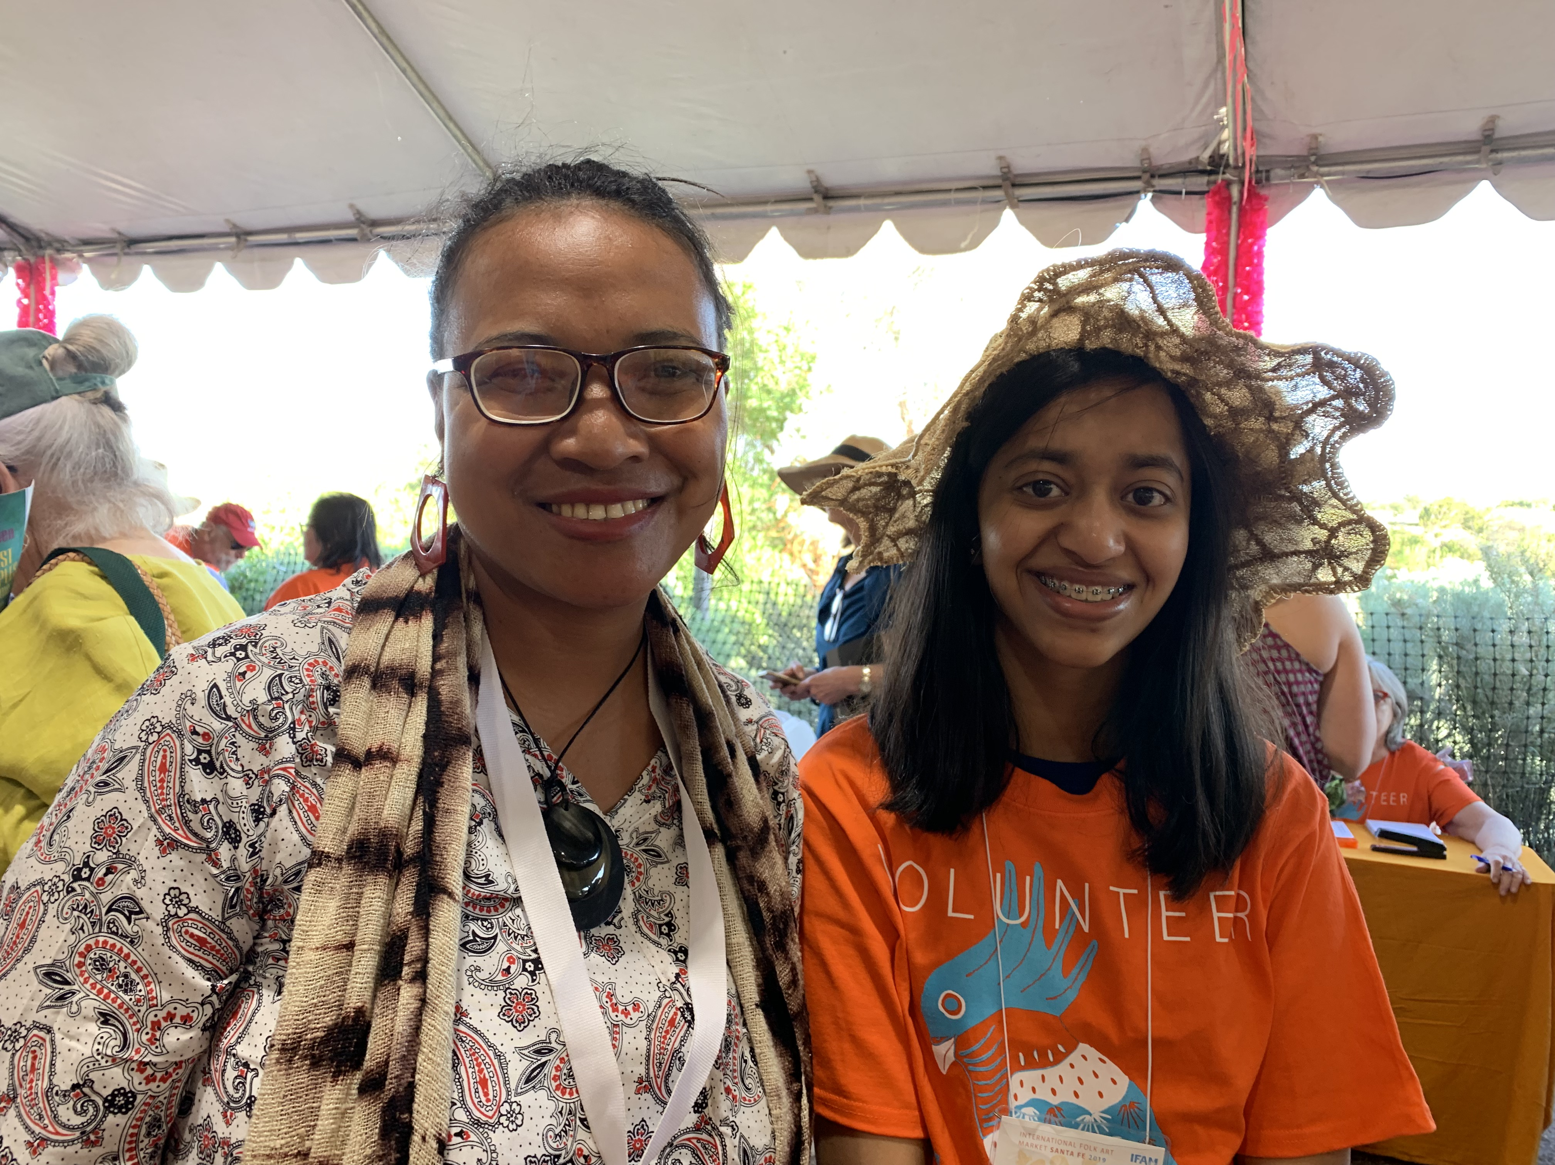

CPALI ANNUAL REPORT
2019

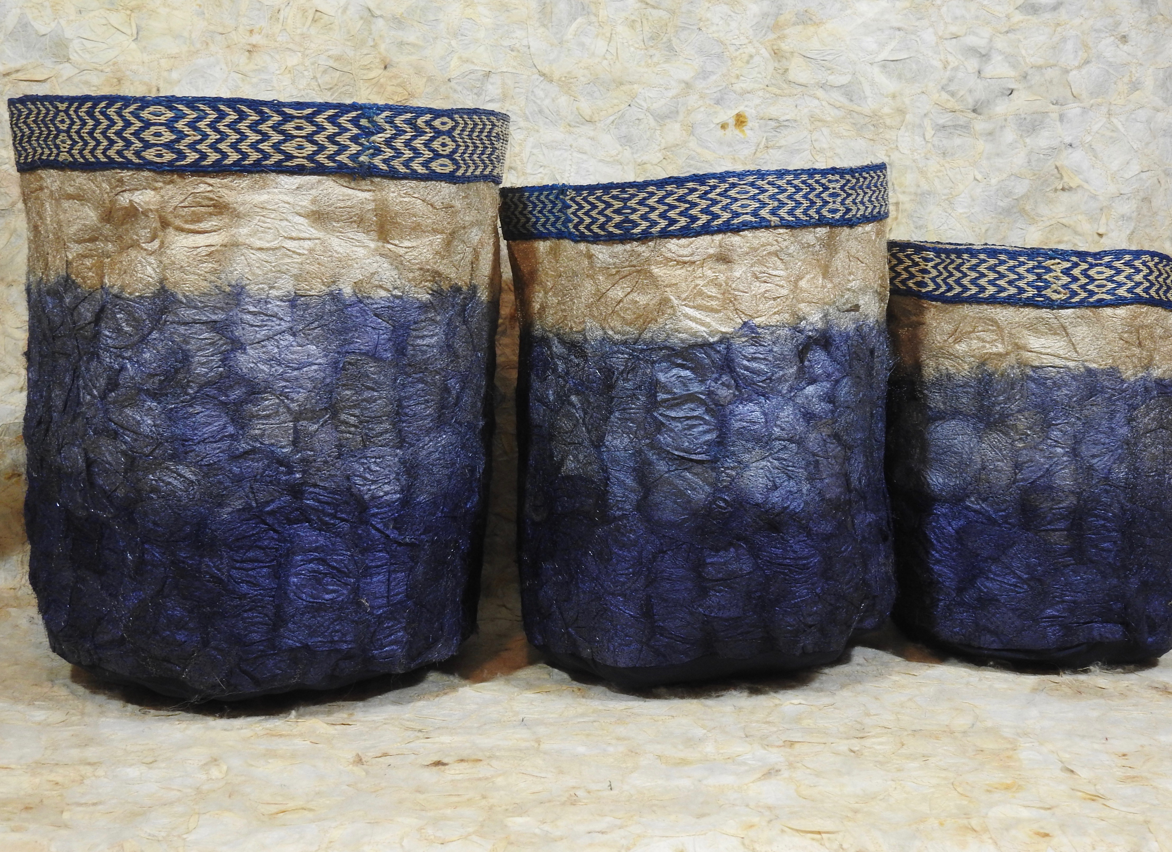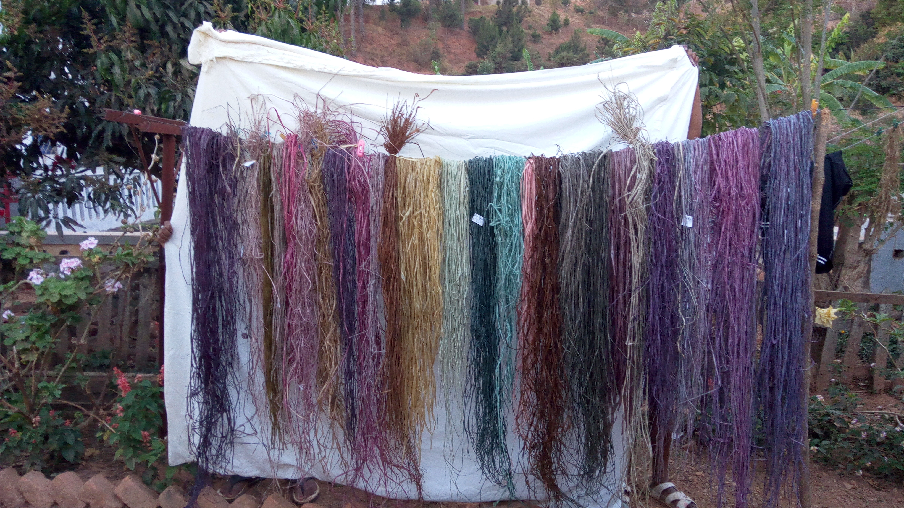p
CPALI Mission
Conservation through Poverty Alleviation, International (http://www.CPALI.org) is an international non-profit organization that identifies, develops, and implements new means of income generation for impoverished farmers living in areas of high biodiversity and conservation value. We were founded in 2002, incorporated in Massachusetts in 2003, and approved as a provisionary 501(c)(3) by the US Internal Revenue Service in 2004. CPALI achieved permanent 501(c)(3) status in 2007.
CPALI is dedicated to a community-centered approach to conservation. Our mission is to help impoverished communities farm and transform endemic resources to create sustainable enterprises that benefit farm families and protect endangered ecosystems.
The CPALI vision is to build and test the effectiveness of an innovative environment-conserving enterprise. We have divided our efforts into four areas:
- piloting a silk gardening and textile production enterprise in northeastern Madagascar
- international marketing of the wild-silk products from Madagascar
- building recognition that endemic resource farming can be a successful international conservation strategy
- building SEPALI Madagascar to be a self-supporting conservation enterprise

Resources and Products: The CPALI method begins with identifying native species of plants and animals near the borders of protected areas that can be farmed and developed for commercial products. CPALI’s first product was silk cocoons produced by the native silk moth Antherina suraka. We added Ceranchia apollina and Borocera cajani, which are also collected sustainably.
In 2017, we extended our product base to include Bombyx mori and two additional native species of silkworm as well as raffia and raffia textiles. Raffia is a product of the raffia palm, of which there are about 20 species in Madagascar. We are currently germinating raffia seeds to plant a raffia nursery.
Human Organizations and Incentive Structure: In Maroantsetra, we helped establish an independent local NGO, "Sehatry ny Mpamokatra Landy Ifotony” (Association of Wild Silk Producers of Madagascar), or SEPALIM, which manages training, raw materials growth and distribution, textile production, and cocoon purchases and develops additional income opportunities. In 2015, SEPALIM established a product workshop that now employs approximately 11 artisans.

LETTER FROM THE PRESIDENT

Dear Friends and Colleagues,

CPALI is in its 17th year of working in Madagascar. The project was initially organized to implement an enterprise-based conservation effort that would provide new sources of income for farmers displaced from the Makira Protected Area, today the Makira Natural Park. The CPALI program has persisted through 2 Malagasy presidential elections and one coup d'etat largely by working "under the radar". The program has had to reinvent itself as the prices on fluctuating commodity markets cause SEPALIM farmers to jump from one high value crop to another. The subsistence farmers that we work with cannot afford to commit to just one product because every year the price of the most profitable commodity seems to change.

Mamy Ratsimbazafy, the director of SEPALIM, has brilliantly run all of the organization's activities for several years and continues sourcing cocoons spun by new species found in new sites and expand products to include locally sourced raffia. Lalaina Raharindimby has taken over the women's program and has been equally successful in training others, designing new products and hiring new artisans. Our initial programs focused on farming endemic resources, learning how to work with subsistence farmers and identifying a product that could be marketed in northern markets. That work has all been taken over by farmers in different communities and our in-town team focusses on dyeing, card weaving, sewing silk and making textile products. Our model has changed from only farming caterpillars to primarily sustainable cocoon collection and textile production. In the future the team plans to farm native plants to make pigment extractions to make natural dyes. CPALI has taken a backseat to SEPALIM's day to day operations for the past 3 years and focused on looking for new ways to sell SEPALIM products. We are searching for importers and new buyers, especially in France and the US, who are interested in integrating cocoon-silk and raffia textiles into their collections and sales. We would like to hire a marketer for each of our main products such as placemats and table décor, wall art, art supplies, cocoon.
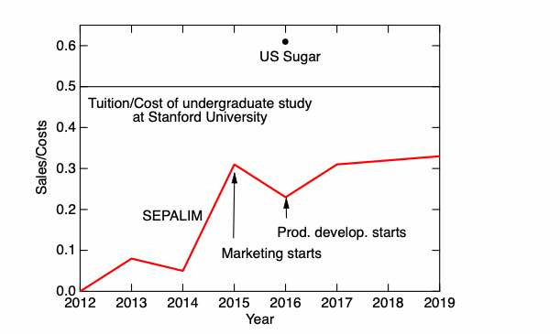
Figure. 1 Progress of SEPALIM to financial stability. the graph above shows Sales/Madagascar team costs in comparison to two enterprises that also rely heavily on subsidies in the US: higher education and sugar farming. SEPALIM is subsidized by our donors but it is advancing to being able to support all of its Madagascar activities. In 2019, 99% of the operating costs of SEPALIM (in Madagascar), including salaries, were covered by sales. Training and marketing are still covered by the CPALI nonprofit mission.

In 2021 I plan to step back from CPALI. SEPALI Madagascar already functions as an independent entity but still needs marketing assistance. Therefore, CPALI would like to hire someone to take over marketing, receiving the products in the US and repacking them to send to our buyers as well as maintaining our inventory management system (Dear systems software), order and invoice and payment processing. The job is perfect for a retiree with marketing and/or retail experience. Please let me know if you are interested. I am trying to put a buyer consortium together to support SEPALIM. We are searching for a few large volume buyers to round out SEPALIM finances. The board is discussing other inputs needed for a smooth transition. If you have any suggestions please let us know.

Thank you again for your support and another great year for CPALI/SEPALIM.

All the best,
Cay

CPALI
Profit & Loss
January through December 2019
TOTAL

Ordinary Income/Expense Income
4000 · Contributions Income 4050 · Restricted
4051 · Global Giving | 7,782.21
Total 4050 · Restricted | 7,782.21
4000 · Contributions Income - Other | 65,531.38
Total 4000 · Contributions Income | 73,313.59
4100 · Grants | 50.00
4300 · Wild Silk Markets | 27,220.67
4800 · Dividend Income | 3,751.64
4900 · Interest Income | 660.58
Total Income | 104,996.48
Expense  6701 · Payroll Tax | 2,851.34
6702 · Payroll Processing Fees | 551.90
6700 · Payroll Expense - Wages | 8,982.34
6100 ·Wild Silk Markets  6160 · Commission | 450.00
6101 · Postage Outbound | 2,737.24
6120 · Product Development  6121 · Postage Inbound | 183.23
6123 · Samples | 67.18
6124 · Supplies | 903.55
6125 · Travel | 2,269.89
6127 · Consulting Prod Dev | 250.00
6120 · Product Development - Other | 2,483.73
Total 6120 · Product Development | 6,157.58
6150 · Product Marketing  6161 · Website | 242.10
6150 · Product Marketing - Other | 2,424.42
Total 6150 · Product Marketing | 2,666.52
Total 6100 · Wild silk Markets | 12,011.34
6200 · Fund raising  6213 · Communication | 144.72
6214 · Gift Purchases | 313.94
6218 · Fundraising Subscriptions | 377.41
Total 6200 · Fund raising  6300 · CPALI Program Development | 836.07

 | TOTAL
6302 · Research CPALI | 43.09
Total 6300 · CPALI Program Development | 43.09
6500 · CPALI G&A  6513 · Communication - G&A | 759.31
6502 · Research | 91.89
6501 · Accounting | 2,070.00
6505 · Bank Fees - G&A | 783.17
6515 · Equipment | 305.00
6520 · Legal Fees | 1,302.64
6525 · Miscellaneous | 205.08
6530 · Meals | 17.23
6550 · Office Expenses | 718.88
6552 · Postage G&A | 148.80
6555 · Reimbursements | -240.33
6565 · Seminars/Training | 2,594.28
6570 · Supplies and Software | 717.07
6575 · Telephone | 185.00
6580 · Travel (overhead travel) | 0.03
6500 · CPALI G&A - Other | 25.49
Total 6500 · CPALI G&A | 9,683.54
6600 · Program Expense - Madagascar  6660 · Seminars & Training | 550.00
6615 · Equipment | 72.85
6620 · Travel | 5,000.00
6650 · SEPALI | 25,611.58
Total 6600 · Program Expense - Madagascar | 31,234.43
6800 · Depreciation Expense | 41.89
Total Expense | 66,235.94
Net Ordinary Income | 38,760.54
Net Income | 38,760.54

Market Report

Year | Total Customers | Net total ($)
2013 | 10 | 4,098
2014 | 19 | 4,453
2015 | 62 | 20,750
2016 | 52 | 15,209
2017 | 73 | 28,672
2018 | 51 | 28,391
2019 | 61 | 27,206

2019 was a great marketing year for CPALI that year that included gallery shows, the International Folk Art Market in Santa Fe, participation in Portland textile month, and the opportunity to sell products at Cargo in Portland. We returned $27,000 sales revenues and continue to build on our investments in product development while lowering our operating costs. In Madagascar and the US. In fact, sales returns covered about 90% of operating costs in the Madagascar workshop that are equal to about one-third of the program costs.

2003 | Cay’s first visit to Madagascar  Initial meeting with potential stakeholders and partners in Madagascar CPALI established as 501(c)3
2004 | Field surveys at Ranomafana National Park Rainforest silk cooperative established CPALI board writes strategic plan
2006 | Field surveys in Makira/Masoala  CPALI House established in Maroantsetra
2007 | Experimental work at CPALI House; Mamy Ratsimbazafy, SEPALIM’s current director, identifies A. suraka host tree  Field trials continue  Permanent field team organized  Demonstration sites established in Maroantsetra Three initial target species identified
2008 | Second demonstration site and nursery is organized at Manambia Mamy completes CPALI training manual  CPALI competes at the World Bank Development Marketplace CPALI achieves permanent 501(c)3 status  Farmer nursery established in Ambodivoangy
2009 | 3-year contracts with first farmers  7 additional farmers join the project  First farmer in Ambodivoangy completes transplant of 1,000 trees First crop of cocoons sold and exported to Thailand
2010 | Sehatry ny Mpamokatra Landy Ifotony Madagascar (SEPALIM) is founded by Mamy Ratsimbazafy, (current SEPALIM Director) SEPALIM introduces silk program in 3 new communities: Marovovonana, Ambinentelo, Amblalmahago  Provisional Patent filed for non-spun textile  Non-spun textile juried and accepted into Material ConneXion’s Worldwide libraries
2011 | CPALI skirt appears in Tara St. James Collection, Fashion Week, NYC SEPALIM begins publishing monthly newsletters for farmers  Tom Corcoran’s CPALI film wins $10,000 prize to support SEPALIM programs Peace Corps volunteer Kerry O’Neill joins SEPALIM in Madagascar  Lalaina Raharindimby appointed to organize women’s program  45 farmers plant a minimum of 250 trees and are awarded SEPALM t-shirts 10 breeders receive ponchos and rain-proof notebooks to keep records  60 women participating in artisan groups are paid for making baskets and nets to support farmers  Lead farmer and lead artisan programs established  First farmer’s picnic and awards ceremony
CPALI TIMELINE
4 farmers produce cocoons
SEPALIM receives SEED Award (UNEP, UNDP, UNESCO)
SEPALIM Equator Initiative Finalist
2012 | SEPALIM purchases permanent demonstration site 15 farmers produce cocoons  Partnership with Stanford Design School; 4 students visit SEPALIM for 2 weeks and discuss new products and more efficient ways to make them  Farmer communities extend to Mahalevona and other sites that border Masoala National Park  First Global Giving project completed after reaching its $50,000 target! SEPALIM bank accepts its first cocoon “deposits”  William Barclay joins the CPALI board  Cornell University partners with CPALI/SEPALIM to sample soil from farmer sites and initiate a long-term monitoring program
2013 | 28 farmers produce cocoons (to date) 300 farmers join SEPALIM  SEPALIM welcomes second Peace Corp volunteer, Donald Quinn-Jacobs  CPALI expands its program mission to include the integrated production of natural resources for food and cash  SEPALIM begins training and introduction of insects for protein  SEPALIM initiates biological studies on Ceranchia apollina, a new species of silk- producing moth  SEPALIM sells 25 m of non-spun textile to Habu Textile James Toupin joins CPALI  CPALI self-imposes an audit by Tonneson and Company Kerry O’Neill joins CPALI as Assistant Director  Heidi MacClean joins the CPALI board CPALI partners with dConstruct
2014 | 32 Farmers producing cocoons, plus 25 collecting cocoons CPALI product debut at DWELL Trade Show in Los Angeles  dConstruct wins eco-choice award from New York Now for wild silk jewelry Architects for Humanity partner with CPALI and design a training center for the Maroantsetra demonstration site  CPALI products are re-approved as Fair Trade by the Fair Trade Federation Repeat textile sales to Habu Textiles and dConstruct jewelry company CPALI introduces Insects for Food program to farmers  Manoely Denis finds the previously rare Ceranchia apollina in abundance and organizes 3 communities to collect cocoons and raise pupae  May Berenbaum, member of CPALI founders board, receives National Medal of Science from President Obama  First farmers double their average annual household income
2015 | James Toupin elected President of CPALI Board  SEPALIM team begins experimenting with both natural and artificial dyes

CPALI joins the Lemur conservation network
CPALI debuts at the Architectural Digest’s Home Design Show with Karen Brown CPALI attends the Fair Trade Federation conference
CPALI is featured in Hand-Eye magazine and ASPIRE magazine
Karen Brown’s silk chair “Natural Selection” is auctioned off for $1,600 dollars Moth Matching Kickstarter campaign is launched and funded
dConstruct launches a new jewelry line of SEPALIM silk in green and purple Mamy’s rearing book is translated into English
Tim Barclay’s children’s book on wild silk farming translated into Malagasy (CPALI moved to next line)
CPALI silks are Certified Wildlife Friendly
CPALI develops table runners and placemats and sells the first line to ABC Carpet and Home
CPALI launches a wholesale site
International design consultant Docey Lewis begins to experiment with SEPALIM silks and creates a new line of dyed products
CPALI sells over $20,000 of silk in 2015 to individuals and retailers
SEPALIM silk production increases from 300 meters in 2014 to 490 meters in 2015 SEPALIM’s silk production workshops run every week in 2015 with a team of local artisans
2016 | Docey Lewis travels to Madagascar to teach SEPALI Madagascar how to dye textiles Pricing of textiles re-evaluated and lowered to increase volume sales  Rafia textiles are adopted into product mix  Madagascar team receives a grant from US Embassy in Madagascar to purchase looms and sewing machines to take program directly to villages  Docey Lewis develops 6 product lines for SEPALI that include lighting materials, handbags, gift ties and tags, textile arts for the leisure industry and fine arts, art papers for artsits;  CPALI establishes commercial partnerships with Color by Amber and Gold Leaf Design SEPALI becomes a Full Circle partner  Rouge Foundation, WCS and CPALI establish children’s conservation art program  Landy Dia, silk farming book by Tim Barclay, is introduced in village schools and libraries; SEPALI Madagascar held two group readings at its headquarters  Rogue Foundation, CPALI and WCS auction paintings and SEPALI Madagascar’s textile arts at the Rogue Gallery in New York  CPALI’s donors surpass all previous giving allowing Docey Lewis to return to Madagascar in 2017 and continue team training  CPALI begins to build Tanana brand
2017 | -Cyclone Enawo devastates northeastern Madagascar on 3 March. CPALI donors donate $3000 to Medair towards the purchase of 150 wash kits for immediate use. In addition, SEPALI Madagascar provides materials and labor to repair a local bridge. Using funds from donors, SEPALI was able to purchase and ship 8 new mattresses to the Ambinentelo hospital.  -Docey Lewis and Catherine Craig return to Madagascar in April to hold a second artisans workshop in Maroantsetra. During 2017 the team has purchased raffia mats from a village outside of Tana that Docey visited to extend a SEPALI partnership  -Docey teaches the SEPALI team how to build a standing loom that is later copied with funds awarded by the US Ambassador. Two additional looms are built  -Docey Lewis shows CPALI/SEPALI cocoon textiles at NY ICFF artisan showcase; Donna Karan purchase textiles for Urban Zen  -IBU designs and sells shibori raffia cosmetic bags made by Madagascar and US teams  -Mamy and Lalaina participate in Aid to Artisans Market readiness program in New York  The training included market trends, pricing, and critiques of SEPALI products by experienced buyers  The Insects for Food partnership held working meeting at the Madagascar Biodiversity Center focused on building insect rearing enclosures, collecting local crickets and exploring potential funding opportunities in Madagascar  SEPALI plants Tsidimy seeds to begin raising “Sakondry” at the SEPALI demonstration site
2018 | -Linda Cartwright visits SEPALI Madagascar and writes a comprehensive article about the program for Wild Fibers Magazine  -Docey returns to Madagascar to help team prepare for NY Now, held I August 2018  Tanana welcomes Sanjo Silk and Diane Sanderson to the team. Sanjo is now the Canadian and US distributor for all undyed silk  -Whitman College's Sheehan Gallery hosts "Requiem for a Rainforest". The exhibit included photographs by Nick Garbutt, Safidy Andrian, 4, silk sculptures by Mandy Coopes-Martin, and non-spun cocoon silk and raffia textiles. Catherine Craig gave a lecture for Whitman's Parents Day "Nature inspired cocoon silk and raffia textiles"  - Docey Lewis visited Whitman College for two days to give two lectures highlighting her work with SEPLI Madagascar as well as her career as a textile designer and artist,  -Safidy Andrian also visited Whitman College to discuss his work with the SEPALI team as well as his career as a photojournalist in Madagascar;  -CPALI exhibited Andrian's photographs at the Columbia Arts Gallery "identity" exhibit in addition to cocoon silk and raffia textiles.  Lalaina Raharindimby was selected by the International Folk Art Market to represent the SEPALI Madagascar team and sell products in 12-14 July 2019. Please join us for this festive event!  -SEPALI program website is revised and beautiful! www.sepalim.org  - SEPALI sells 97 items and 3,207 units; Sales returned $24,902 to the program
2019 | - Chad Brown joins the CPALI board of directors  - January – SEPALI exhibit at Columbia River Gallery in Hood River  - Mamy outlines a flexible management plan to allow for more personal time for workers and to add new workers to the SEPALI team  - SEPALI exhibition at Brasserie restaurant Walla Walla  - SEPALI team prepares $15000 of materials for the 2019 International Folk Art Market in Santa Fe  - Koti designs produce striking handbags from Ceranchia dense weave silks  - Mamy gives invited talk at Association for Tropical Biology meeting in Antananarivo and generates interest from other Madagascar NGO's to replicate the silk program or possibly partner with SEPALIM  - SEPALI Madagascar is finalist for Equator Initiative  - Lalaina joins CPALI US and Sanjo team to market goods in Santa Fe  - Wildlife Friendly asks SEPALI to provide their Malagasy partner with raffia  - Mamy and Lalaina travel to southern Madagascar to learn natural dyeing techniques for raffia fibers and silk  - CPALI/SEPALMI are accepted to participate in Portland's Textile Month in October  - Cay participates in shibori workshop to develop new buyers for cocoon silks as well as skills to relate to the team; several DVD's are purchased and sent to the team for additional training  - SEPALIM captures the interests of several new foreign buyers in the wall covering business  - Mamy outlines tough new product goals of 5000m of cocoon silk (multiple types of cocoons) for 2020 that could insure SEPALIM's financial success as long as buyers are identified  - Portland textile month hosts 3 events on behalf of SEPALI: Julie Beeler, Portland textile artist, holds a workshop to teach other Portland artists how to dye cocoon silk with natural dyes  - Cargo, Inc holds reception and month long sales event for SEPALIM at store and returns all profits to SPALIM  - Sylvan Dyers Circle designs 6 hanging cocoon silk textiles that are auctioned on behalf of CALI/SEPALIM  - Craig spends November/December at Sitka Center for Art and Ecology in Otis Oregon to begin writing book describing the CPALI/SEPALIM Program  - SEPALIM sales return $31,000 to program, about 99% of SEPALIM's operating budget  - Tanana brand and logo awarded a trademark
Donors
We give special thanks to the Kenney Family and the Barclay Family Trust for their continued and substantial support that has made CPALI/SEPALIM a reality.

$1-$99 | $100-$999 | >1000+ | >5000+
Yael Lubin  Claire Kremen  Douglas Kolozsvari  Leslie Brunetta  Allison Thiel  Laura Leibensperger  Yael Lubin  Frances Chew  Jon Barry  Linda Harrar  Camille Hunter  Diane Monico  Susan Monahan  Jillian Schiffman  Ann Hanson  Amanda R Anderson  Marie Keutmann  Sally Brown  Caroline Lewis  Elizabeth H  Anonymous  Mary Sears  James Toupin  William Kenney  Ken gross  Amelia Thrall  James Burns  Martha Saxton | Anonymous  Elizabeth H  Anonymous  Mary Sears  James Toupin  Nancy Merrick  Carole Levin  William Kenney  Ken gross  Amelia Thrall  James Burns  Martha Saxton  Ann Vander Stoep  Robert Weber  Margery M Craig  Catherine Caufield  Jeanne Blamey  Peter Speert  Gary D Bernard  Jane K Pidduck  Brent Opell  Marshall C. Milligan  Larry Wiberg  Peter and Faye Speert  Andrew and Barbara Moore  Isabel Stirling | Eleanor Farquhar  Heidi Maclean  Helen Kenney  Diana Wheeler  Global Giving  May Berenbaum  Henry and Sue Bass  Listgarten family  Edward Kenney  Caroline Kenney  Judy Munzig  Caroline Pidduck | Anonymous

In-Kind Support
Harvard University, LL Tonneson and Company, Docey Lewis Designs, Tim Barclay, May Berenbaum PhD., Leslie Brunetta (Clerk), Catherine Craig PhD, Heidi MacLean (CFO), Walter Simons, Amelia Thrall, Robert Weber PhD, Andry Ralijaona, Chad Brown

How You Can Help CPALI
CPALI is reviewed on GuideStar and Great Nonprofits’ websites, and our financial data is posted on the www.CPALI.org website. We appreciate any and all donations of volunteer assistance, money, equipment, stocks (please contact C. Craig for Merrill Lynch account details), frequent flyer miles, and Amtrak miles. All of your gifts and donations are tax deductible. Donations can be made by credit card through Global Giving, Network for Good, PayPal directed to craig@cpali.org, or by a check made out to CPALI and sent to:
CPALI
712 S. Palouse St.
Walla Walla, WA 99362

